A000-Am, S-Colombia-Tairona-Tumbaga-Woman standing, with frontal apron, necklace, hairnet, diadem, holding a water flask-1000-1500 CE

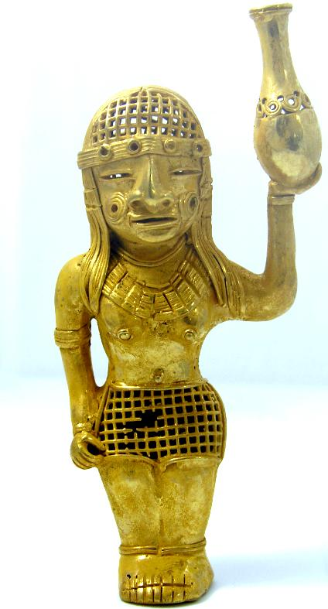 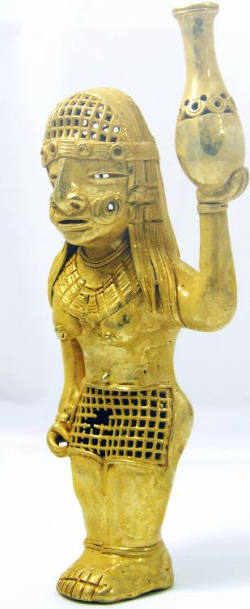

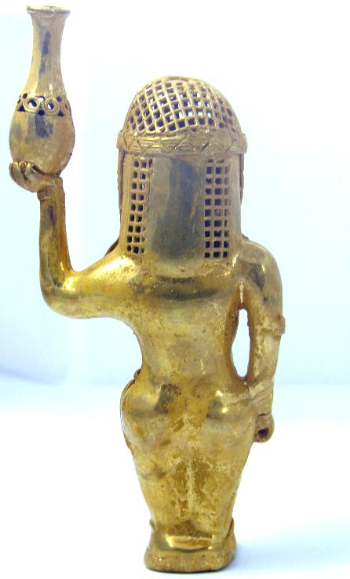 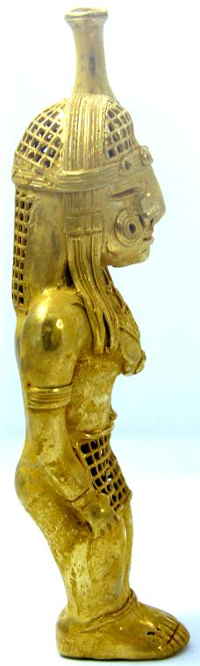

Figs. 1-4. Colombia-Tairona-Tumbaga-Woman standing, with frontal apron, necklace, hairnet, diadem, holding a water flask

Case No.: 7

**Accession No.**

**Formal Label:** Colombia-Tairona-Tumbaga-Woman standing, with frontal apron, necklace, hairnet, diadem, holding a water flask

**Display Description:**

Woman standing, with frontal apron but no back apron showing she is a maiden, a gold block necklace, a full hairnet, held in place with a 4 jewel studded diadem, holding a water flask. Her face is scarified with keloids according to her tribal affiliation; she wears bracelets on each hand and anklets on each foot and on her right arm she wears a band. The flask is decorated with a band of concentric circles in its mid section and it has a globular base. She may have held a staff in her right hand as her fingers appear in a curved position.

**LC Classification:**

**Date or Time Horizon:**

**Geographical Area:**

**Map:**

**GPS coordinates:**

**Cultural Affiliation:**

**Media:** GOLD, SILVER AND COPPER ALLOY

**Dimensions:** 85 mm x 48 mm x 55 mm

**Weight:** 83.2 GRAMS

**Condition:**

**Provenance:**

**Discussion:**

**References:**